Weekly Worksheet Solutions

Student ID: 1915677
Student Name: Niraj Chudali

Week Number: 3
Worksheet No / Name:4/ CIS016-1 - Principles of Programming / CIS096-1 – Principles of Programming and Data Structures / PAT001-1 – Principles of Programming - 2019/2020 Exercise Sheet 3

Exercise No 1 /:
Commented Code
import java.util.*;

public class Car{
// The properties of a car
String model; // the car model
String colour; // the car color
int numOfPassengers; // number of passengers in the car
double amountOfGas; // the amount of gas in the car

// Constructor of a car object. This constructor takes 2 parameters( mod and col) to set the model and the colour of the particular car object.

public Car(String mod, String col, double gas, int passengers)
{
model = mod;
colour = col;
amountOfGas = gas;
numOfPassengers = passengers;
}

// Initialising the values

public void initialise()
{
numOfPassengers = 0;
amountOfGas = 16.5;
}

// Sets the amount of gas. This method changes the amount of gas property of the object, but does not return anything.

public void setAmountOfGas(double amount) {
amountOfGas = amount;
}

// Gets the current amount of gas. This method returns the current amount of gas as a double value.

public double getAmountOfGas()
{
return amountOfGas;
}

// This adds a passenger to car.

public void addPassenger() {
numOfPassengers++;

}

// This removes a passenger from your car.

public void removePassenger() {
numOfPassengers--;

}

// This returns the current number of passengers as an integer value.

public int getNumOfPassengers() {
return numOfPassengers;
}

// This returns the model of the car as a String object

public String getModel() {
return model;
}

// This returns the colour of the car as a String object

public String getColour() {
return colour;
}

public static void main(String[] args)
{
//initialise Scanner object
Scanner scannerObject = new Scanner(System.in);

//requesting string value from user
System.out.println("Hello! Please enter your car model");

//read 1 string
String modelInput = scannerObject.next();

//requesting string value from user
System.out.println("Now insert your car colour");

//read 1 string
String colourInput = scannerObject.next();

//result values input by user
System.out.println("You said your car model is a "+modelInput+", and its colour is "
+colourInput+".");

//request a value from user
System.out.println("What is the amount of gas in your car? (Enter the amount in litres)");
double gasInput = scannerObject.nextDouble();
System.out.println("Thank you! How many passengers do you have in the car?");
int passengerInput = scannerObject.nextInt();

// Create a new Car object and initialise it using values from user

Car myCar = new Car(modelInput, colourInput, gasInput, passengerInput);
// myCar.initialise();
System.out.println("Your car is a " + myCar.getModel()
+ " and it is " + myCar.getColour() + ".");

// Get and print the amount of gas

double gasAmount = myCar.getAmountOfGas();
System.out.println("The current amount of gas is " + gasAmount + " litres.");

// Add and print a new passenger

myCar.addPassenger(); // a new passenger
myCar.addPassenger(); // and another one
System.out.println("Two passengers joined your car");
int passengers = myCar.getNumOfPassengers();
System.out.println("Your car carries " + passengers
+ " passengers right now.");

// Refill the tank, print new value

myCar.setAmountOfGas(gasAmount + 30); // fill the tank
gasAmount = myCar.getAmountOfGas();
System.out.print("You refilled your car! "); // note the use of print()
System.out.println("Now the current amount of gas is "
+ gasAmount + " litres.");

// Remove one passenger, print updated number of passengers

myCar.removePassenger(); // 1 passenger stepped off
System.out.println("A passenger got out of the car");
passengers = myCar.getNumOfPassengers();
System.out.println("Your car carries " + passengers
+ " passengers right now.");
}
}

Evidence of Testing

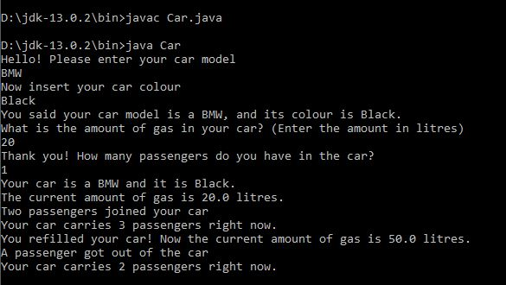

Explanation / Discussion of Solution

Exercise No 2 / Student class:

Commented code

import java.util.*;

public class Student{
// The properties of a student

int studentID;//student ID
String studentName;//student name
int studentLevel;// Student level of study

//Constructor of a student object takes 3 parameters as values to initialise the particular student object

public Student(int id, String name, int level)
{
studentID = id;
studentName = name;
studentLevel = level;
}

//method to get ID information
public int getID()
{
return studentID;
}

//method to get student name
public String getName()
{
return studentName;
}

//method to get student level
public int getLevel()
{
return studentLevel;
}

//method to calculate grade average
public double gradeCalc (double grd1, double grd2, double grd3, double grd4, double grd5)
{
double average = (grd1 + grd2 + grd3 + grd4 + grd5) / 5;
return average;
}

//main method
public static void main(String[] args)
{
//initialise scanner object
Scanner keyboardInput = new Scanner(System.in);

//request values from user
System.out.println("Hello! Welcome to the University!");

System.out.println("Please enter your name:");
String nameInput = keyboardInput.nextLine();

System.out.println("What is your student ID?");
int idInput = keyboardInput.nextInt();

System.out.println("Thank you! What is your level of study?");
int levelInput = keyboardInput.nextInt();

//create a new instance of student and initialise it using values given
Student newStudent = new Student (idInput, nameInput, levelInput);

//echo back input values
System.out.println("Your ID is: "+newStudent.getID()+
". Your name is: "+newStudent.getName()+
", and your level of study is: "+newStudent.getLevel());

//request student grades
System.out.println("Please we would like to know your grades");
System.out.println("Insert first grade");
double grade1 = keyboardInput.nextDouble();
System.out.println("Insert second grade");
double grade2 = keyboardInput.nextDouble();
System.out.println("Insert third grade");
double grade3 = keyboardInput.nextDouble();
System.out.println("Insert fourth grade");
double grade4 = keyboardInput.nextDouble();
System.out.println("Insert fifth grade");
double grade5 = keyboardInput.nextDouble();

double average = newStudent.gradeCalc(grade1, grade2, grade3, grade4, grade5);
System.out.print("The average of your grades so far is ");

System.out.print("The average of your grades so far is ");
System.out.printf("%5.2f",average);
System.out.print(".");
}
}

Evidence of Testing

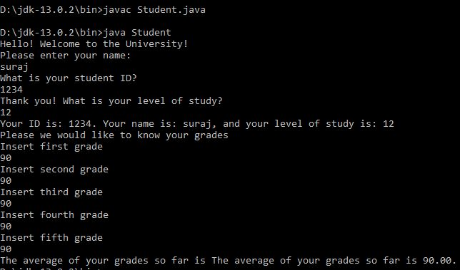

Explanation / Discussion of Solution

